Methods

Objective 1: Assess how varying salinity, temperature, and light levels influence microscopic bull kelp growth and development at the hatchery stage.

To assess the effects of salinity, temperature, and light on kelp growth and development in the hatchery, we set up a full factorial experimental design crossing three temperatures (5°C, 8°C, 11°C) and four light intensity regimes (constant 30 μmol photon·m-2·s-1, increasing from 20 to 30 μmol photon·m-2·s-1, constant 20 μmol photon·m-2·s-1, increasing from 20 to 60 μmol photon·m-2·s-1) during year 1 in Kodiak (at the NOAA AFSC lab). During the first year in Juneau (at UAF Pt. Lena Laboratories) and the second year for Kodiak (at the Prince William Sound Science Center), we replicated this full-factorial design without the dynamic light regimes (increasing from 20 to 30 μmol photon·m-2·s-1 & increasing from 20 to 60 μmol photon·m-2·s-1). Each temperature-light treatment combination had three replicate spools of seed string that were cultured for two months. Spools were seeded with spore solution at a density of 100 spores per mL in October of each year. During the second year, however, gametophyte growth was heavily compromised due to contamination, so the experiment was restarted in January using existing gametophyte cultures started four months prior. Due to limited gametophyte mass available, only two spools were able to be seeded for each temperature-light treatment combination during the second Kodiak hatchery season.
Spools seeded with kelp were allowed to grow out for 8 weeks in year 1, and 10 weeks in year two, as outplanting was delayed in year 2 due to poor weather windows. The condition of bull kelp seed on the seed string was checked biweekly under a microscope in year 1, and at weeks 2, 4, and 10 in year 2. During each microscope check, we took 5 random photos that were later used to count the number of and measure the length of gametophytes and sporophytes using ImageJ. During year 2 in Kodiak, we also calculated weekly percent cover of seed string using ImageJ.

Objective 2: Determine how the growth and harvest of adult bull kelp is affected by different hatchery conditions
After 8 to 10 weeks of growth, the cultivated kelp spools were transferred to be outplanted onto spreader bar arrays owned by Kelp Island AK in Kodiak and Sea Quester in Juneau (Figure 1). Before outplant, we measured the 20 largest sporophytes on each spool using calipers as well as photographed each spool to determine percent cover of seed string (calculated using ImageJ).
Once outplanted, the bull kelp lines were allowed to grow for up to 6 months. During the first year, kelp was outplanted in Kodiak on December 12, 2024 and harvested on May 30, 2025, and due to limited farm space, only static light treatments were outplanted (constant 30 μmol photon·m-2·s-1 & constant 60 μmol photon·m-2·s-1).. Kelp was outplanted in Juneau on January 16, 2025, but no growth was observed over the following months, so no kelp was harvested from Juneau. In the second year, kelp was only outplanted at the Kodiak farm, but due to delays from hatchery contamination, kelp was in allowed to grow on the farm for two months less than the previous year (Table 1).
At harvest, we collected data on the number of bull kelp individuals collected and the bulk wet weight of each outplanted line. Each of these metrics was divide by 7.62 (m) to calculate average density (number of individuals per meter) and average yield (weight in grams per meter). We also collected data bull kelp morphometrics, including blade length, stipe length, pneumatocyst (bulb) diameter, and sub-pneumatocyst (sub-bulb) diameter.

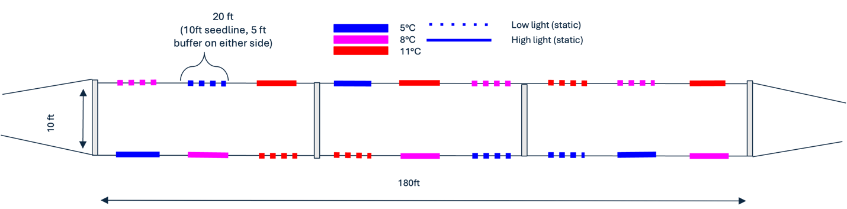
Figure 1: Spreader bar array design. Seed line was outplanted onto a two line spreader bar array, that consisted of two 180 foot lines spaced 10 feet apart by an aluminum spreader bar. Each 180 foot line held nine 25 foot segments of seedline spaced 10 feet apart.
Table 1: Dates of outplanting and harvest for each year.
Farm | Year | Spore Seed Date | Outplant Date | Harvest Date | Age of Kelp at Outplant (since spool seeding) | Age of Kelp at Harvest (since spool seeding)
Sea Quester | 2025 | October 14, 2024 | January 16, 2025 | N/A | 94 | N/A
Kelp Island | 2025 | October 7, 2024 | December 12, 2024 | May 30, 2025 | 66 | 235
Kelp Island | 2026 | January 16, 2026 | March 26, 2026 | July 9, 2026 | 69 | 174

